Test Case: tc001_SPX_Dev5_Crear_Requisicion_Spot_Tipo_Cobro_CC
Step 1 - Enter username and password and click to button Enter : Credentials Entered
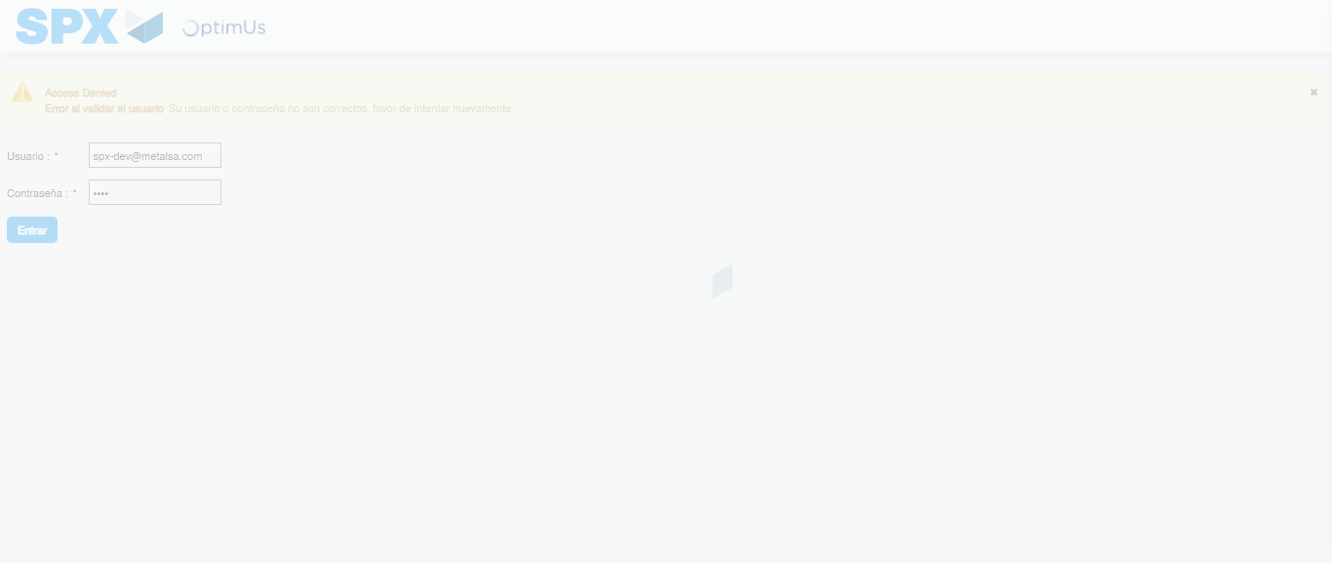Image file-name: QC_Testing-tc001_SPX_Dev5_Crear_Requisicion_Spot_Tipo_Cobro_CC-1789482570628

Step 2 - Select to UEN and Access to Spot Buy Requisitions : UEN Correctly selected and Correct access
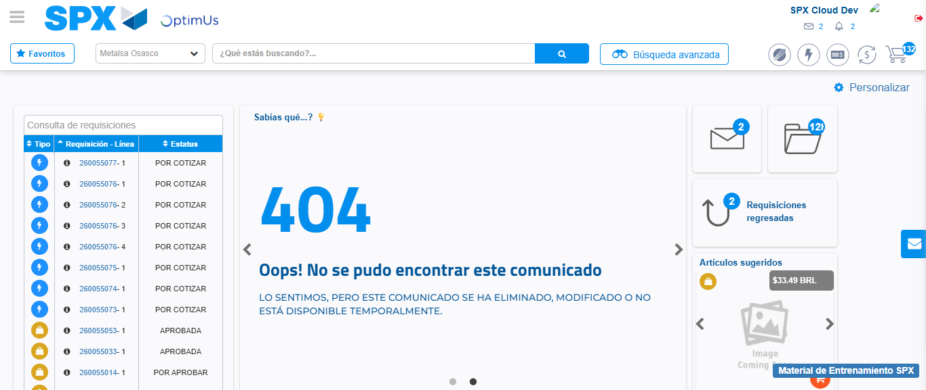Image file-name: QC_Testing-tc001_SPX_Dev5_Crear_Requisicion_Spot_Tipo_Cobro_CC-1789482593897

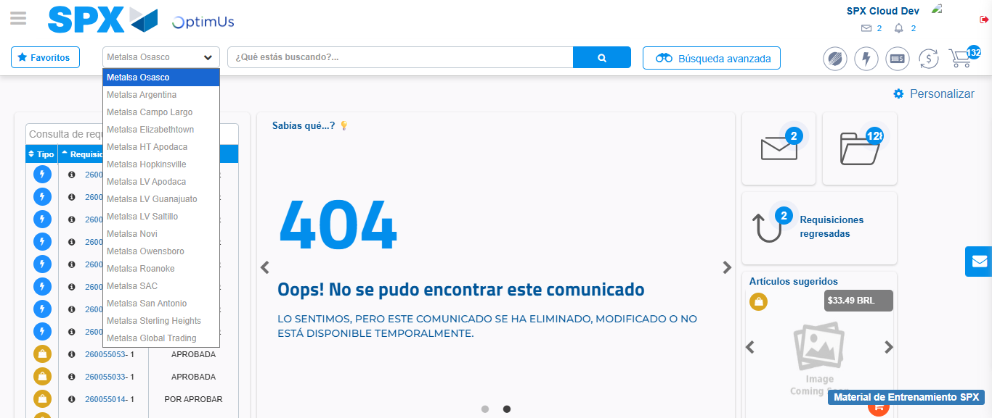Image file-name: QC_Testing-tc001_SPX_Dev5_Crear_Requisicion_Spot_Tipo_Cobro_CC-1789482594406

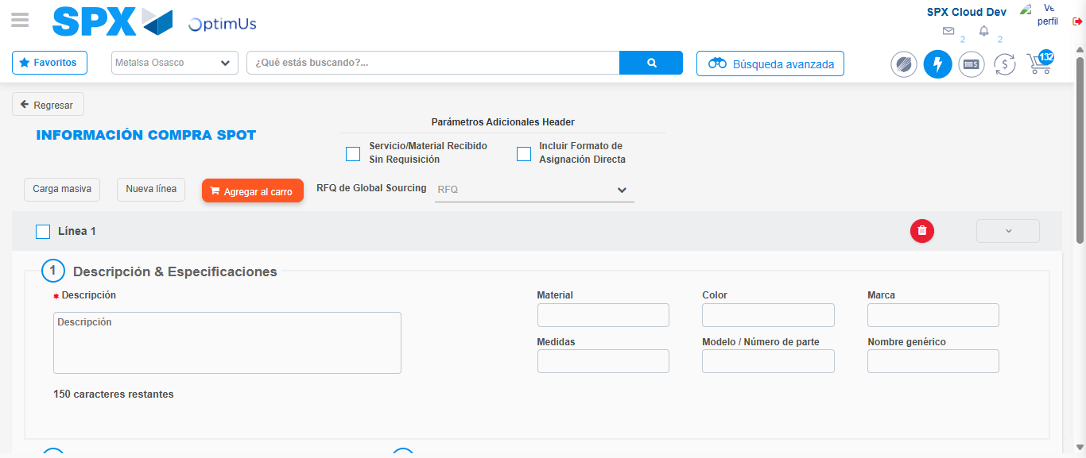Image file-name: QC_Testing-tc001_SPX_Dev5_Crear_Requisicion_Spot_Tipo_Cobro_CC-1789482598458

Step 3 - Data Capture Spot Buy Requisition : Data captured correctly
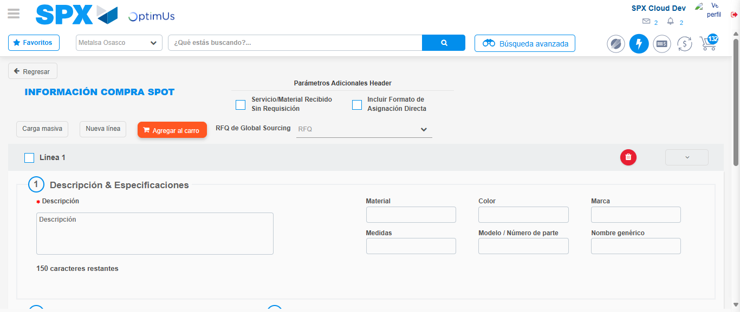Image file-name: QC_Testing-tc001_SPX_Dev5_Crear_Requisicion_Spot_Tipo_Cobro_CC-1789482598720

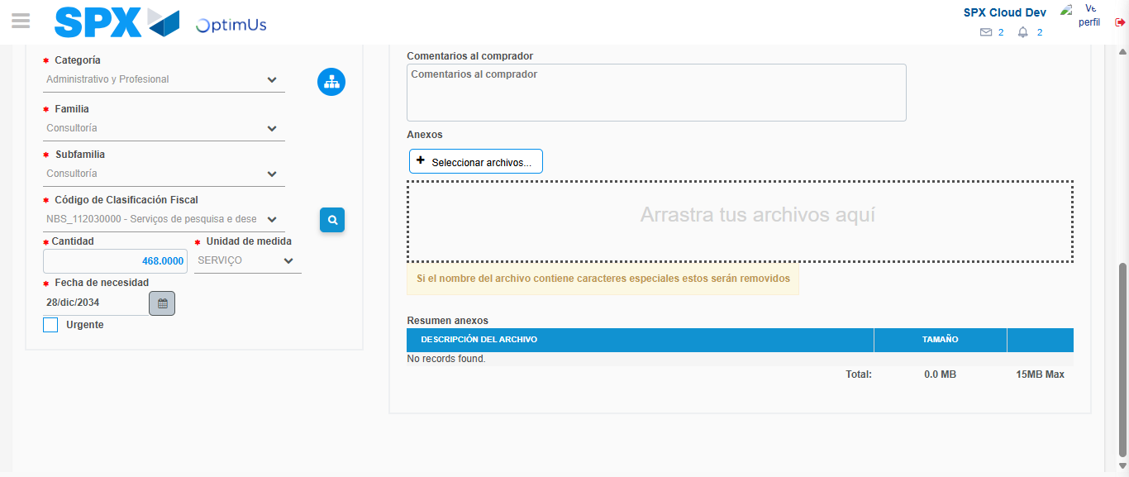Image file-name: QC_Testing-tc001_SPX_Dev5_Crear_Requisicion_Spot_Tipo_Cobro_CC-1789482615974

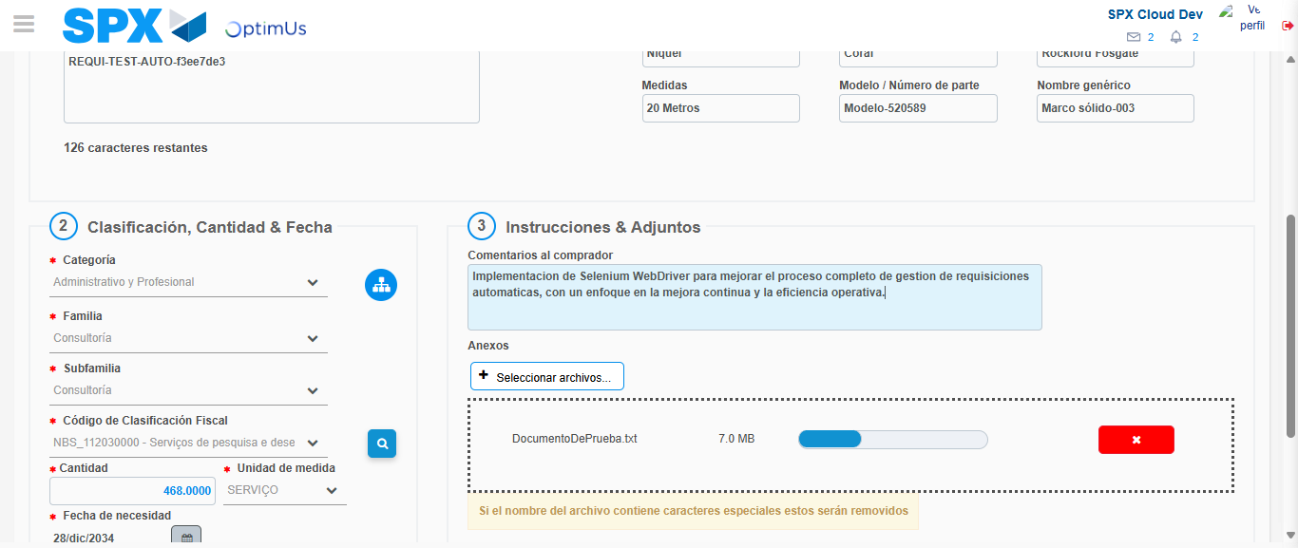Image file-name: QC_Testing-tc001_SPX_Dev5_Crear_Requisicion_Spot_Tipo_Cobro_CC-1789482616944

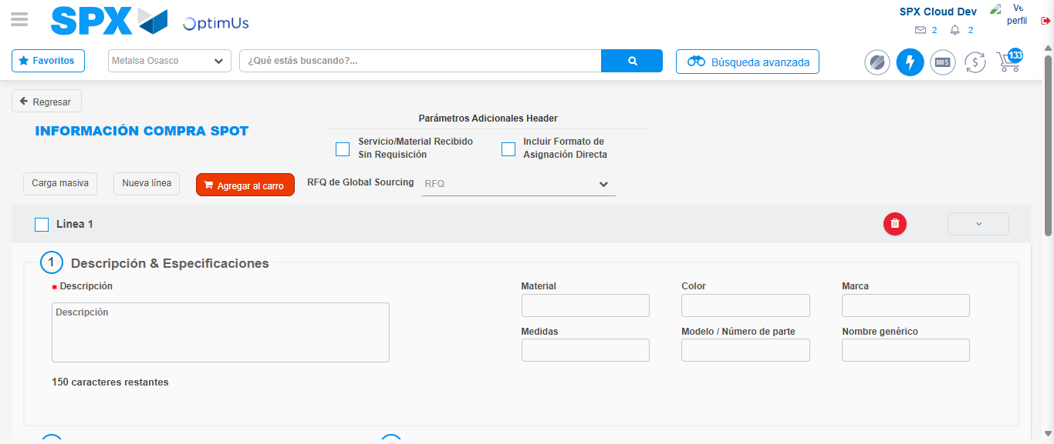Image file-name: QC_Testing-tc001_SPX_Dev5_Crear_Requisicion_Spot_Tipo_Cobro_CC-1789482631994

Step 7 - Return to Main Page SPX : Return to Main Page SPX
Image file-name: QC_Testing-tc001_SPX_Dev5_Crear_Requisicion_Spot_Tipo_Cobro_CC-1789482593897

Image file-name: QC_Testing-tc001_SPX_Dev5_Crear_Requisicion_Spot_Tipo_Cobro_CC-1789482594406

Image file-name: QC_Testing-tc001_SPX_Dev5_Crear_Requisicion_Spot_Tipo_Cobro_CC-1789482598458

Image file-name: QC_Testing-tc001_SPX_Dev5_Crear_Requisicion_Spot_Tipo_Cobro_CC-1789482634274

Image file-name: QC_Testing-tc001_SPX_Dev5_Crear_Requisicion_Spot_Tipo_Cobro_CC-1789482634475

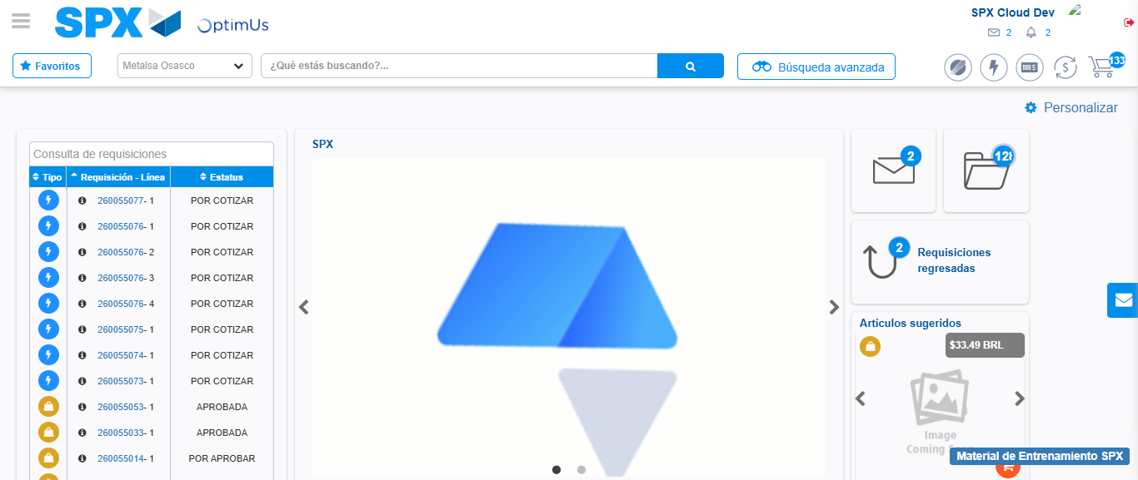Image file-name: QC_Testing-tc001_SPX_Dev5_Crear_Requisicion_Spot_Tipo_Cobro_CC-1789482655720

Step 8 - Log Out : Log Out SPX
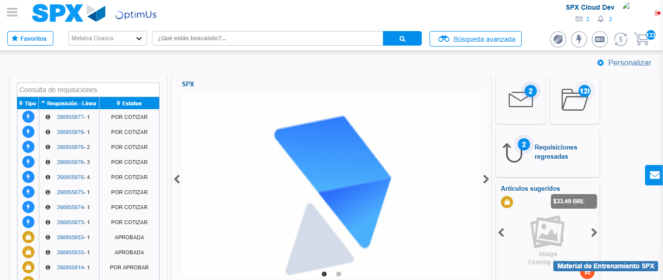Image file-name: QC_Testing-tc001_SPX_Dev5_Crear_Requisicion_Spot_Tipo_Cobro_CC-1789482655986

